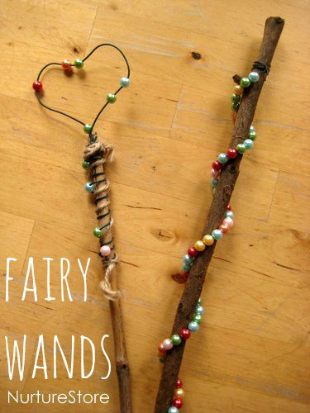
How to Make a Fairy Wand
Here’s how to make a magic wand for imaginary play:
- Start by gathering some sticks
- Choose carefully! Hold each stick and when you feel the magic tingle, you know that is the right wand for you.
- Use garden wire to make a special shape for the end of your wand.
- Wrap the ends of the wire around the stick to hold it in place. Take care with the ends of the wire as you are making your wand.
- Decorate your wand any way you wish. You can use beads, string, yarn, leaves. The limit is your imagination.

