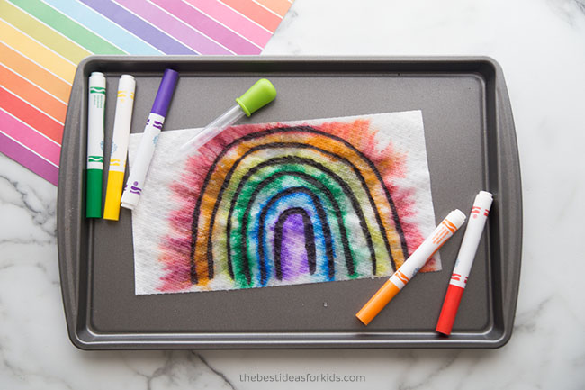

How to do a Surprise Rainbow Activity
Paper Towel You Drop in Water
For this activity you will need 1 sheet of paper towel you can fold in half. Washable markers, a black permanent marker and a dish or bowl with water.
1. First, fold over 1 sheet of paper towel.
2. Start by drawing lines for a rainbow with the black permanent marker. You need permanent marker so that the black marker will not bleed.
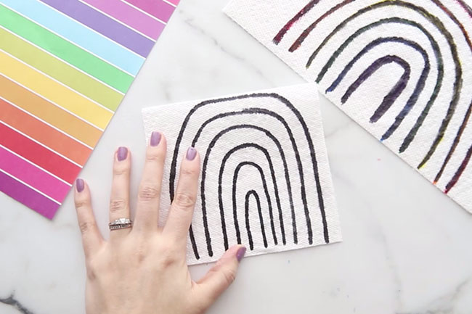
You want to press hard or go over the lines a few times so that it bleeds through to the second layer of the paper towel.
3. On the bottom layer, start coloring in your rainbow with washable markers. You need washable markers here so that it will bleed through to the top layer.
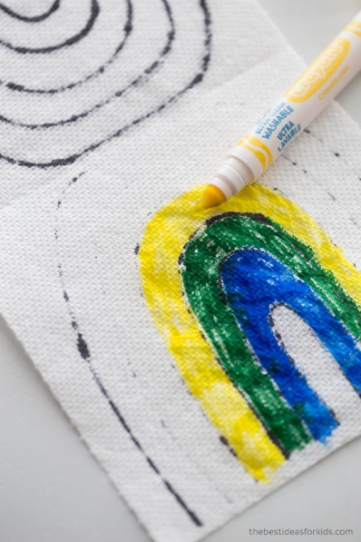
4. Keep adding all of the colors to the bottom layer.
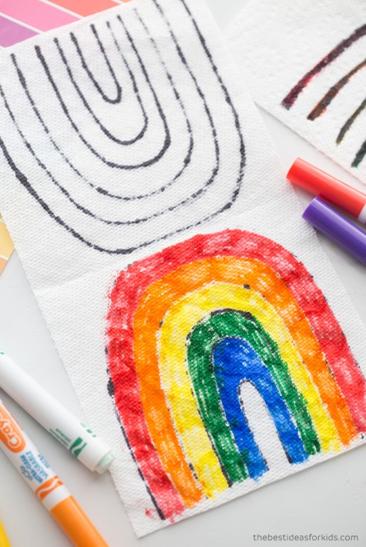
5. Now it is ready to drop in water! Add some water into a dish or bowl. Then drop it into the water and watch the magic! Your rainbow will appear before your eyes.

